**WhatsApp Group Monetization - Analysis, Insights and Recommendations**

|  |  |
| --- | --- |
| Team | Group 1 |
| Product Managers | Sylvia, Fatimah, Eberechi, Farouk, Grace, Simisola, Olamide, Heaven, Williams, Esther, Ehi. |
| Data Analysts | Blessedsarah Omolola, Damilare Adefowope, Diseph Dum. |
| Designers |  |
| Engineering |  |



**Overview**

This document focuses on analyzing user preferences and experiences to guide the setup of **ChatProfit**, a WhatsApp Group Monetization Platform. The analysis provides insights on **group members’** demographics, interests, ad engagement behaviors, and **group admins**’ goals and challenges in managing and monetizing their groups. It also covers **advertisers’** objectives and common challenges on social platforms, aiming to ensure ChatProfit’s features align with user needs and enhance product-market fit.

**Methodology**

To gain insights into user preferences, experiences, and challenges related to group monetization on WhatsApp, we conducted a structured survey targeting three key segments: Group Members, Group Owners/Admins, and Business Owners/Advertisers. The survey aimed to capture a comprehensive understanding of the needs, attitudes, and behaviors within each segment to inform the design and setup of ChatProfit, our group monetization platform.

The survey was distributed across targeted channels and gathered a total of **126 responses**, segmented as follows:

* **Group Members**: 49 responses, representing individuals who actively participate in WhatsApp groups and interact with in-group content, including advertisements.
* **Group Owners/Admins**: 37 responses, representing those who manage WhatsApp groups and are interested in group growth, member engagement, and monetization strategies.
* **Business Owners/Advertisers**: 40 responses, representing brands or individuals seeking opportunities to advertise within targeted communities to enhance reach, brand visibility, and conversions.

[**Survey Response**](https://docs.google.com/forms/d/172zs-K7mC6xivaORw_qzyzdEyXojco8cgbGK6tM_C9U/edit)

[**Access the Excel Files here**](https://drive.google.com/drive/folders/1JBdCj1M3KYF1DvWekD0gdSDy14BjProc?usp=sharing)

**Target Audience**

* **Group Owners:** People who manage WhatsApp Groups, especially those with large, engaged members.
* **Advertisers:** Brands, Companies or Individuals looking to reach targeted communities for their products or services.

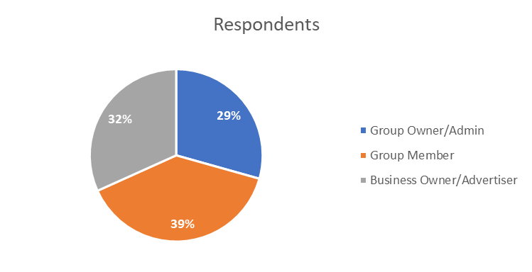

**Group Member Analysis: Insights on Ad Perception and Engagement**

**Demographic Overview**

The analysis reveals distinct demographic characteristics among group members, with the majority falling within the 18-34 age range. Specifically:

* **18-24 years**: 15 respondents
* **25-34 years**: 25 respondents
* **35-44 years**: 1 respondent
* **45-54 years**: 0 respondents
* **55 and above**: 1 respondent

This younger audience profile indicates a tech-savvy and social-media-oriented demographic, likely to be comfortable with online interactions and more open to engaging with digital content. Younger audiences are generally more receptive to advertisements, especially when the ads are relevant to their interests.

**Group Interests and Motivations for Participation**

Understanding the core interests and motivations of group members provides a clearer picture of what type of content, including advertisements, resonates with them. The survey data reveals several key motivations:

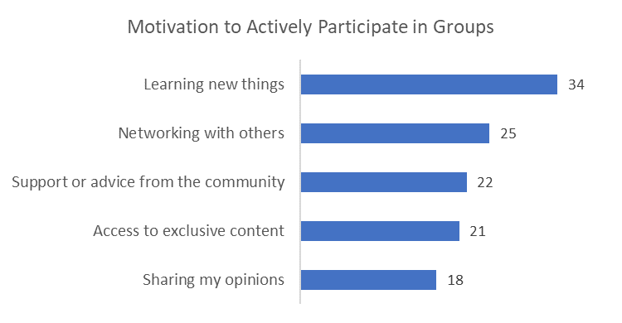

* **Knowledge Sharing and Learning**: For many, groups are a source of valuable information and skill-building. Participants in educational, career-focused, or tech groups join specifically to learn and gain insights from others, seeking relevant content that contributes to personal or professional growth.
* **Networking and Professional Growth**: Group members with a focus on networking, particularly in industry-specific groups, value opportunities to connect with like-minded individuals and potential collaborators. They are often motivated to participate in discussions, share resources, and explore content that can aid in their professional development.

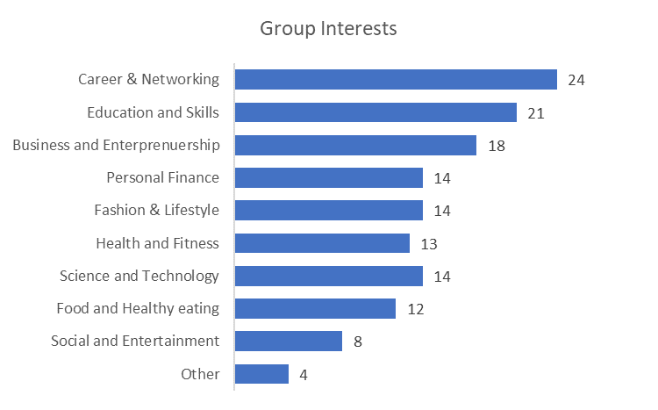

**Ad Perception and Attitudes**

Group members’ attitudes toward seeing ads on their groups were mixed, with preferences that highlight the importance of relevance and non-intrusive ad formats:

* **Relevance of Content**: Many group members noted they were more likely to engage with ads that align closely with their interests or the group’s primary purpose. For example, members of a cooking-related group preferred ads on food products or kitchen appliances, whereas those in tech or education-focused groups found ads on gadgets or courses more acceptable.

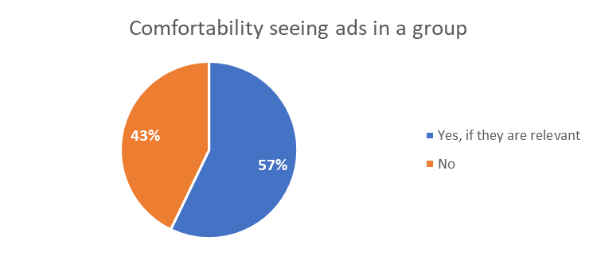

* **Preferred Ad Format**: When it comes to ad formats, text and image ads were more acceptable than videos, likely due to the non-intrusive nature of static content. Video ads, while engaging, might disrupt the group interaction flow, which is a key factor in maintaining a positive user experience in messaging-based communities.

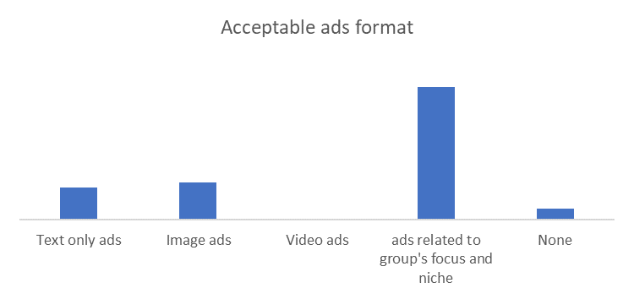

**Engagement and Willingness to Interact with Ads**

Group members showed varying levels of willingness to interact with ads:

* **High Engagement for Relevant Ads**: Members indicated they would click on or engage with ads that genuinely add value or interest them. Products or services that are group-related—such as discounts on group themes, special offers, or limited-time promotions—encouraged more interaction.

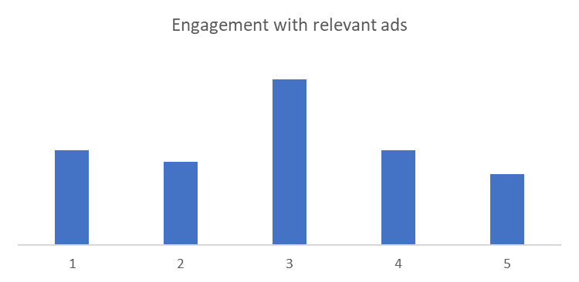

* **Ad Fatigue Awareness**: While some members expressed tolerance for seeing ads, there was a recurring theme of “ad fatigue,” especially among frequent group users. This suggests a need for balance in ad frequency, ensuring members do not feel overwhelmed, which could negatively impact group retention.

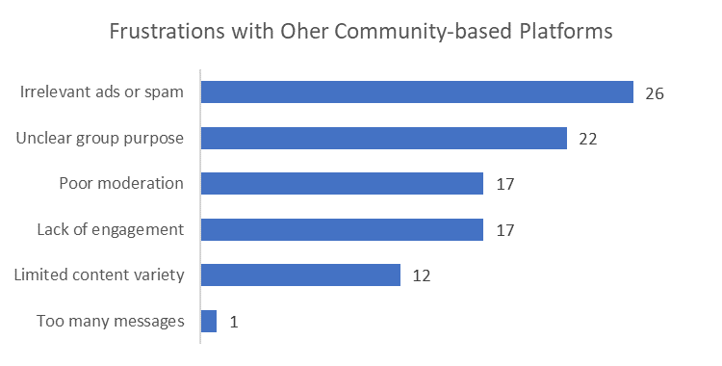

**User Suggestions and Recommendations for Improvement**

Members shared valuable insights into what would enhance their experience with in-group ads:

* **Ad Placement Preferences**: Many suggested placing ads strategically to avoid interruption, such as displaying them between group discussions or allowing users to interact at their discretion.
* **Transparency and Control**: A notable portion of respondents valued control over their ad experience, expressing interest in settings that allow them to choose the types of ads they see or even the frequency. Features enabling users to provide feedback on ads or customize their ad preferences can create a more user-centric approach to ad delivery.
* **Interactive Content and Exclusive Offers**: Respondents showed a higher inclination toward ads offering some interactive experience—polls, short surveys, or personalized recommendations. Additionally, exclusive deals for group members could boost ad engagement and offer added value.

**Growth Potential and Projections**

Considering the group members’ positive response toward well-placed, relevant ads, there is promising potential for this platform to grow in terms of ad engagement and monetization:

* **Projected Engagement Rates**: With a younger demographic that is more inclined toward ad engagement, we estimate a **10-15% click-through rate** for highly relevant ads, higher than the industry average.
* **Long-term Ad Retention**: By adhering to member suggestions on ad frequency and transparency, there’s potential to maintain a high user retention rate, as members feel respected and in control of their ad experience.
* **Opportunities for Premium Ad Placements**: Given the preferences for ad type and placement, offering premium slots for advertisers could maximize revenue, especially from brands that align with the group’s theme and interests.

**Conclusion and Recommendations**

The analysis reveals that group members are open to ads that add value, align with their interests, and maintain a non-intrusive presence within their group experience. By implementing user-friendly ad settings, balancing ad frequency, and offering exclusive deals or interactive content, the platform can create an engaging environment that benefits both members and advertisers.

**Group Owners/Admins Analysis**

**Content Focus of the groups**

The content focus of the groups reveals a diverse range of interests among the group owners/admins, with Business and Entrepreneurship having higher responses, followed closely by Social and Entertainment and Education and Skills. This indicates that group admins are primarily geared towards providing value in areas that can foster professional growth and community engagement. However, the relatively lower focus on Health and Fitness, Fashion & Lifestyle, and Food and Healthy Eating suggests that these areas may be underserved, presenting potential opportunities for niche content development.

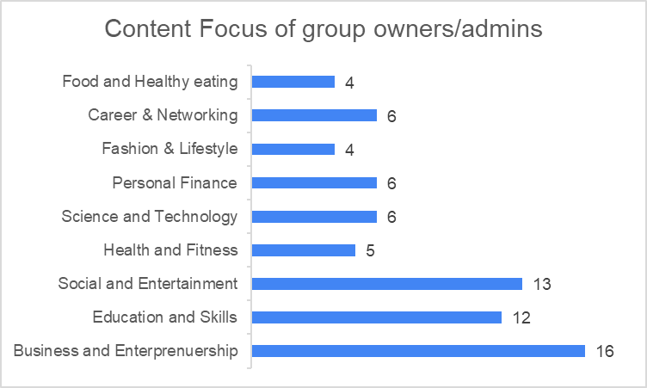

**Primary Goals for Managing Groups**

The survey reveals that Growing Membership and Increasing Engagement and Interactions are the top priorities for group admins. This shows that building a large and active community is important to WhatsApp group success. Ads that showcase products or resources designed to enhance engagement can resonate with admins focused on increasing engagement and interactions within their groups. Monetizing group activities and building brand authority falls under the secondary considerations of group admins.

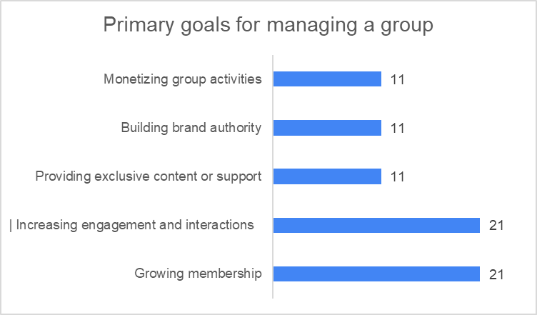

**Interest in Monetizing Groups by Allowing Ads or Promotions**

The majority of respondents expressed interest in monetizing their groups through ads or promotions. This indicates a significant demand for monetization options within the platform. A smaller group indicated a "maybe" response, suggesting a more cautious approach to monetization. They might be concerned about potential negative impacts on the group's community or brand.

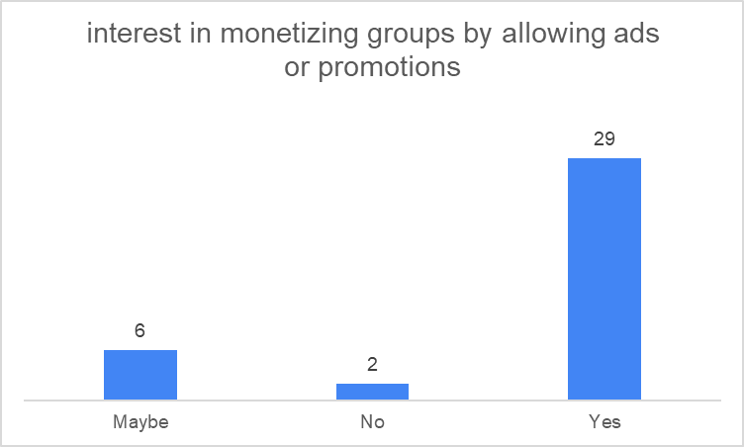

**Challenges Faced in Monetizing Their Groups**

The group admins indicated some of the biggest challenges they face while trying to monetize their groups. The analysis revealed that privacy of group members is the biggest challenge faced by group owners or admins when it comes to monetizing their groups. A lot of respondents are also faced with the challenge of creating a balance between monetization strategies and group interaction as monetization tends to be a potential disruption of group activities.

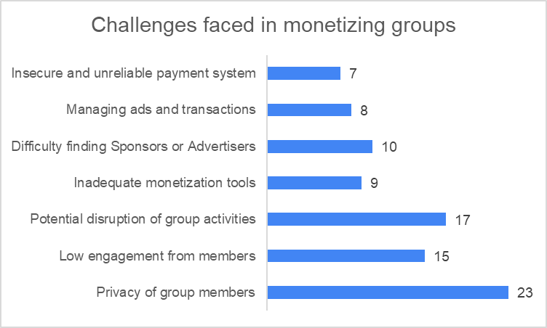

**Ads Preference**

The survey data shows that Relevant products/services is the most preferred type of ad by group admins and owners, indicating a strong preference for ads that are directly related to the group's interests and needs. Sponsored content is also a preferred option, suggesting that group admins are open to sponsored content as long as it is high-quality and relevant.

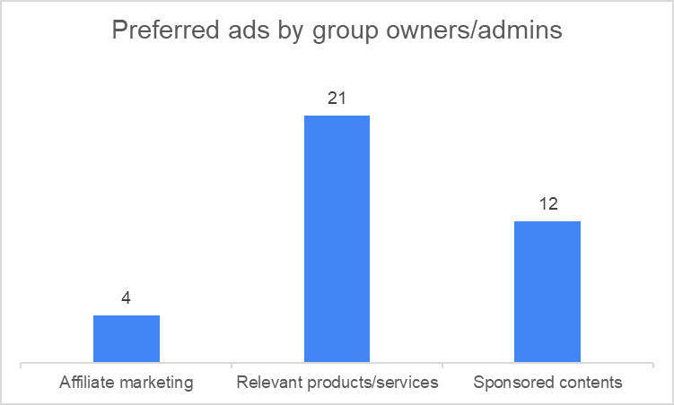

**Preferred Features on a Group Management/Ad Platform**

Group admins/owners highlighted the different kinds of features they would like to have on a group management/ad management platform.

**Group Statistics and demographics insights:** This feature is the most desired among the respondents, indicating a strong need for data-driven insights to understand and manage groups effectively.

**Secure and seamless payment system:** This is the second most desired feature, highlighting the importance of a reliable payment system for monetization and transactions within the platform.

**Member analytics and insights:** This feature is also highly sought after, suggesting a need for tools to understand and engage with group members.

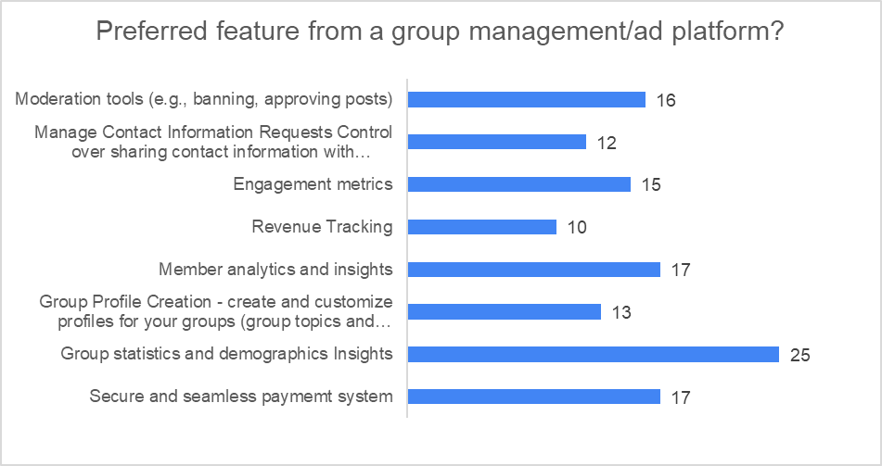

**Funding Method for Group**

The funding methods utilized by group owners and admins reveal significant insights into their financial strategies and the challenges they face.

**Out of Pocket:** A majority of the respondents reported funding their groups out of pocket, indicating a strong personal investment in the success and sustainability of their communities. This reliance on personal finances suggests that many admins may be hesitant to implement monetization strategies due to concerns about disrupting group dynamics or member engagement.

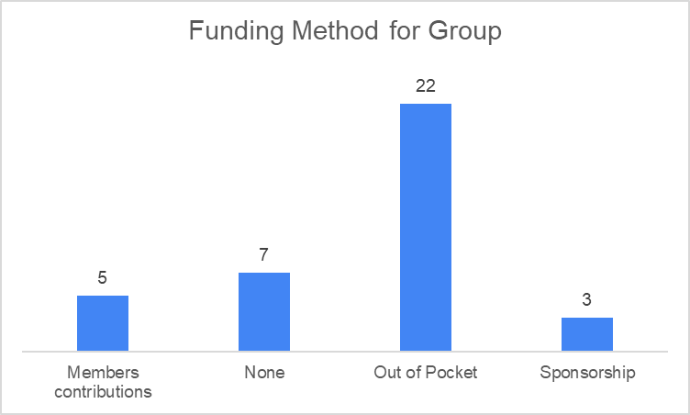

Additionally, some of the respondents indicated that they currently have no funding sources, which may lead to challenges in maintaining group activities and resources. The survey also indicates that the least number of respondents rely on sponsorship and voluntary contributions from their members to fund their group activities.

**Projection for Group Owner/Admin**

The trend analysis shows a projected growth of interested group admins over a seven-year period. It shows a steady increase in the number of admins interested in monetizing their groups. The average percentage increase in the projected number of interested admins over the next seven years is approximately 40.83%. This steady growth suggests that the platform has significant opportunities to engage with a growing audience

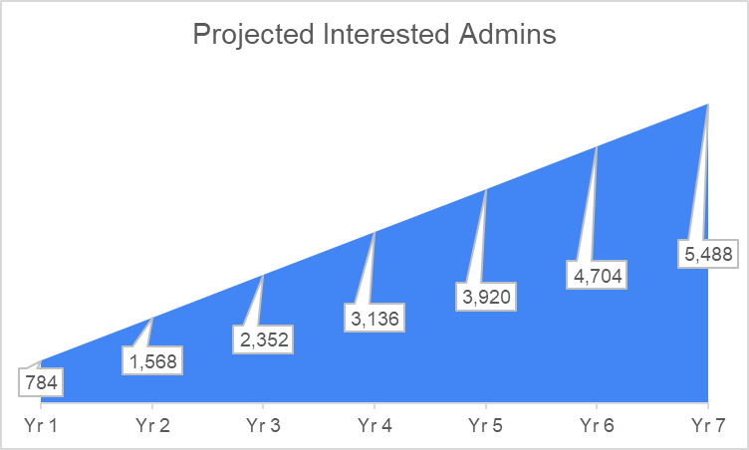

**Recommendations**

**Engagement-Driven Advertising:** To address group admins' primary goals of growing membership and increasing engagement, advertisers on our platform should focus on ads that enhance community interactions. Ads and promotions  that facilitate discussions, webinars, or interactive content can be particularly effective. This approach not only aligns with the admins' goals but also helps to mitigate the perceived disruptions caused by monetization efforts.

**Privacy and Balance in Monetization:** Since privacy concerns are the foremost challenges for group admins, advertisers must prioritize transparency and ethical ad placement. Ads should be designed to respect group dynamics, offering value to both the admins and their members. Providing options for unobtrusive advertising, such as sponsored posts that integrate seamlessly into group discussions, can help maintain a balance between monetization and community interaction.

**Feature Development for the Platform:** The platform should prioritize developing features that cater to the needs expressed by group admins. Implementing robust group statistics and demographic insights can empower admins with data-driven decisions, while secure and seamless payment systems can enhance trust and facilitate monetization. Additionally, member analytics tools can help admins engage their communities more effectively by understanding member preferences and behaviors.

**Business Owners/Advertisers Analysis**

Our survey found that **95% of advertisers** had prior experience using social media platforms for advertising. This is a strong indication that our target market is already familiar with digital marketing, and we can expect that they understand the basic features and functionalities of social media ads.

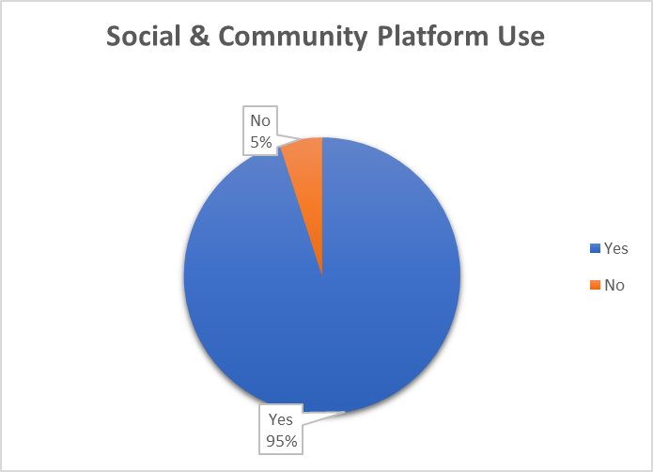

Within this 95%, the most commonly used platforms were **WhatsApp Groups, Instagram, and Facebook**. This insight is valuable because these platforms serve as benchmarks for how advertisers view social media advertising. Understanding the features they appreciate and those they find lacking, can inform our platform's feature design to align with and exceed their expectations.

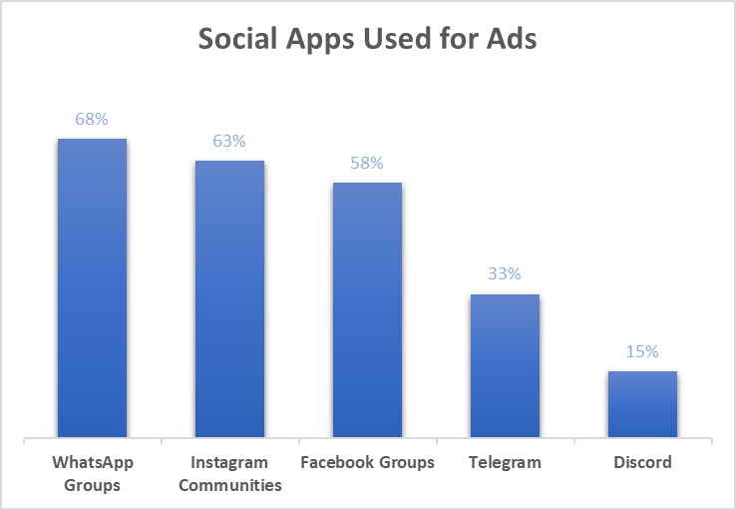

**Advertising Goals**

The survey shows that advertisers prioritize sales conversions and brand awareness as their primary goals; This insight reinforces the need for our platform to prioritize tools that drive conversions and build brand presence.

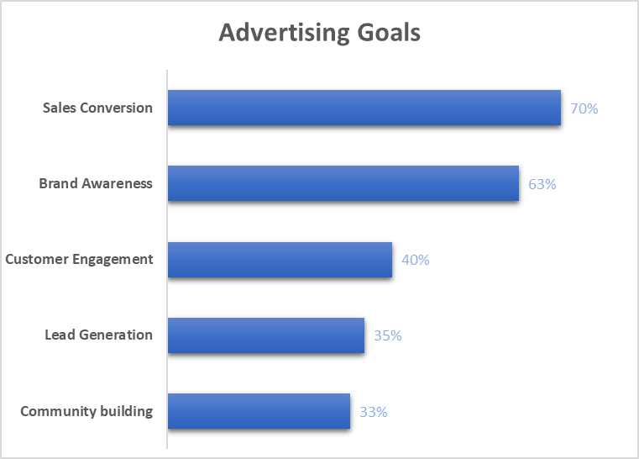

Providing features such as analytics and engagement insights can support advertisers in measuring these goals, which will make our platform more attractive to them.

**Challenges faced by Advertisers**

Advertisers reported several challenges with current ad platforms, chief among them being high costs and limited targeting options.

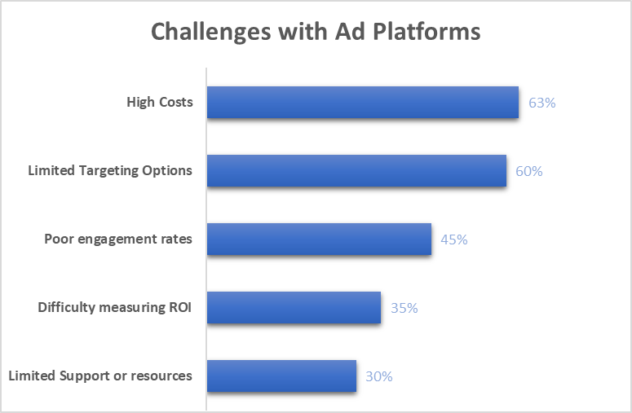

This presents an opportunity for our platform: if we offer more affordable ad placements with versatile targeting capabilities, we can position ourselves as a cost-effective alternative in the market. Our product model emphasizes broad exposure across various groups, an approach that could directly address these advertiser concerns by improving reach and flexibility.

To differentiate our platform, we can also address other pain points by providing built-in engagement tools, transparent ROI analytics, and reliable customer support. This approach could improve advertiser satisfaction and loyalty over time.

**Preferred Pricing Model**

The data showed the pay-per-click (PPC) pricing model as the most popular choice among advertisers, though it was only selected by 35% of the population. This lack of a strong majority suggests that advertisers are likely open to alternative pricing models; we could offer a combination of pricing models to accommodate these variations.

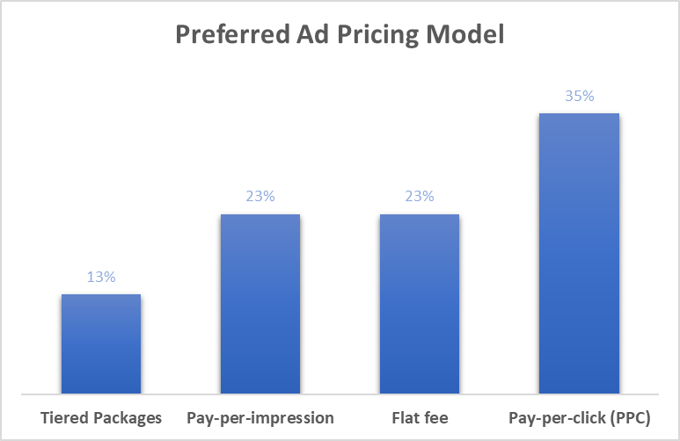

**Key Performance Metrics**

For 76% of advertisers, conversion rates and engagement rates are the primary metrics for measuring ad performance.

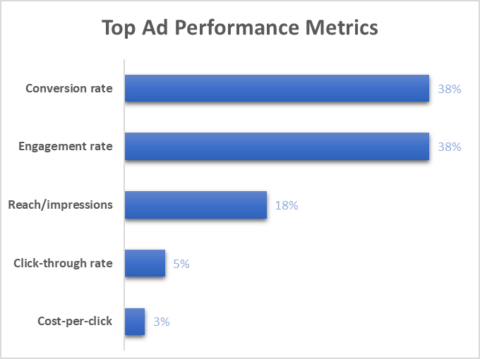

This emphasizes the need to design features that enhance these metrics, such as targeting options that focus on high-engagement groups and analytics that highlight conversion-related insights.

**Factors Influencing Advertisers’ Interest**

When evaluating group advertising opportunities, advertisers are most attracted to engagement levels within a group, followed closely by group size. This is crucial for our platform, as it highlights the need to provide clear indicators of group engagement and size.  Interestingly, age demographics were of limited concern to most advertisers, indicating that they value audience activity over demographic targeting. Our platform should thus prioritize engagement-based metrics and group reach indicators to attract advertisers effectively.

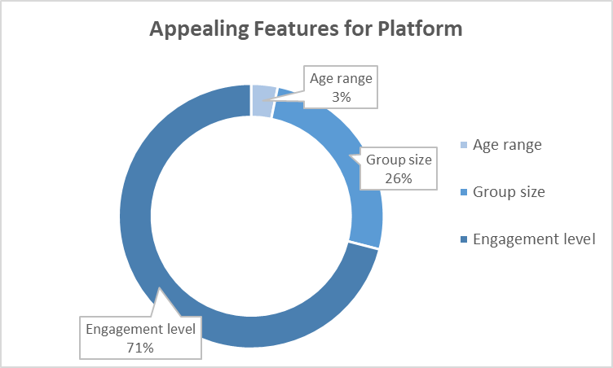

**Revenue Projections**

Based on the survey data and our estimated advertising model, all things being equal, the projected revenue for the platform is approximately **₦410,000 in the first year**, with a forecasted increase of **85%** over seven years. This projection reflects the potential for our startup to capture a substantial share of the social advertising market as it matures.

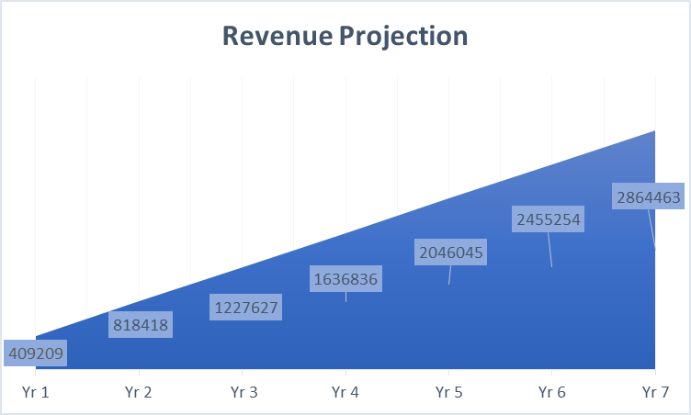

**Recommendations**

* **Feature Development:** Our platform should include tools such as detailed audience insights, group filtering, and interactive ad formats. This could enhance advertisers’ ability to meet these goals effectively.
* **Flexible Pricing:** We should provide various pricing options and allow advertisers to select a model that best suits their budget and objectives. This allows our platform to maximize revenue by catering to a broader range of advertiser needs.
* **User Experience:** Our platform should provide dashboard analytics more focused on engagement and conversion metrics. This could include developing an index to highlight high-performing groups, helping advertisers identify the most active audiences and optimize their campaigns for better results.
* **Customer Support:** Integrating feedback mechanisms and personalized support options could address common pain points identified in the survey, such as difficulties in measuring returns and limited support.

**Market Research for ChatProfit**

[**Access full document here**](https://docs.google.com/document/d/11y4k-dUL4rzZ2kDbSvdt0hVIv9oMyJDAAEDlGVYNhyA/edit)

Social platforms like WhatsApp, Facebook, and Instagram are increasingly being used to promote and sell products, contributing to the rapid rise of social commerce. The global digital advertising market was valued at over $300 billion in 2022, and it's projected to reach $720 billion by 2030, growing at a compound annual growth rate (CAGR) of 13.9% between 2023 and 2030. The market is rapidly expanding due to the increased adoption of digital platforms for branding and advertising, driven by growing internet usage, especially mobile, and rising social media engagement. Digital ad spending in the U.S. alone is expected to surpass $300 billion by 2025, with video, search, and social media as primary channels​

WhatsApp has over 2.7 billion active users worldwide, making it one of the largest platforms for informal commerce and marketing. A survey by Meta revealed that 70% of users communicate with businesses via WhatsApp, indicating a growing intersection between messaging apps and e-commerce.